**Index Page**

**_____________________________________________**

**Name______________________ Roll No.______________Program:_______**

**Section: ___________ Year______________Semester___________________**

**Subject________________________Subject Code:_____________________**

|  |  |  |  |  |
| --- | --- | --- | --- | --- |
| **S.no** | **Objective** | **Date of Submission** | **Remark** | **Faculty Sign** |
|  |  |  |  |  |
|  |  |  |  |  |
|  |  |  |  |  |
|  |  |  |  |  |
|  |  |  |  |  |
|  |  |  |  |  |
|  |  |  |  |  |
|  |  |  |  |  |
|  |  |  |  |  |
|  |  |  |  |  |
|  |  |  |  |  |
|  |  |  |  |  |

**Experiment 1**

**Objective:** Design a simple web page with head, body and footer, with heading tags, image tag (your CV).

**Program : index.html**

<!DOCTYPE html>

<html>

<head>

  <title>My CV</title>

</head>

<body >

  <header>

    <h1>Arpita Tiwari</h1>

    <p>Assistant professor with an experience of 10 years in academics. </p>

  </header>

  <main>

    <h2>Skill Set</h2>

    <ul>

        <li>C/C++</li>

        <li>Java</li>

        <li>HTML/CSS/JS</li>

    </ul>

    <h2>Education</h2>

   <table border="1">

    <tr>

        <th>S.No</th>

        <th>Board of Education</th>

        <th>Class</th>

        <th>Percentage</th>

        <th>year of passing</th>

    </tr>

    <tr>

        <td>1.</td>

        <td>MP Board of Secondary Education, Bhopal</td>

        <td>12th</td>

        <td>74.4%</td>

        <td>2008</td>

    </tr>

    <tr>

        <td>1.</td>

        <td>MP Board od Secondary Education, Bhopal</td>

        <td>10th</td>

        <td>78.8%</td>

        <td>2006</td>

    </tr>

   </table>

</main>

  <footer>

    <p>Mobile number: 798752850</p>

    <p>email: arpita.tiwari@sunstone.in</p>

    <p>Address: 35 Sudama Nagar Indore</p>

  </footer>

</body>

</html>

**Output:**

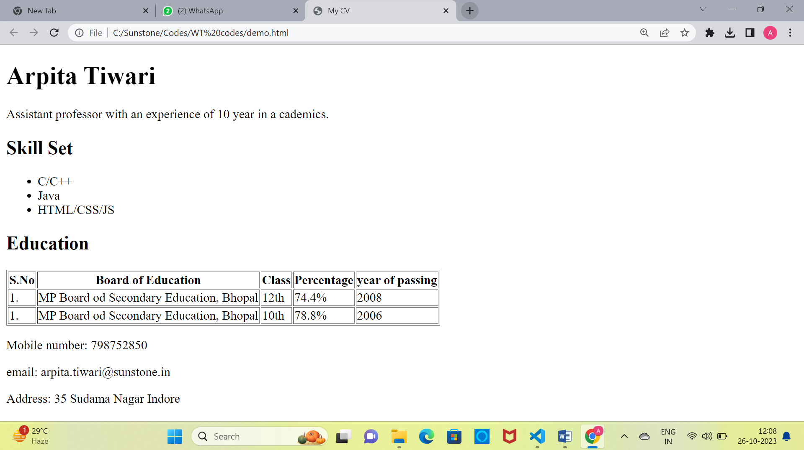

**Note: You Can print the output on single page in landscape layout. Also include <img > tag in your code.**

**Experiment 2**

**Objective:** 2. Design a web site for book information, home page should contain books list, when particular book is clicked, information of the books should display in the next page. (Use <a> tag for )

**Program : index.html**

<!DOCTYPE html>

<html>

<head>

  <title>Book Information</title>

</head>

<body>

  <h1>Book List</h1>

  <ul>

    <li><a href="book1.html">HTML & CSS: The complete referance, fifth edition </a></li>

    <li><a href="book2.html">Book 2</a></li>

    <li><a href="book3.html">Book 3</a></li>

    <!-- Add more book links as needed -->

  </ul>

</body>

</html>

**Program : book1.html**

<!DOCTYPE html>

<html>

<head>

  <title>Book 1</title>

</head>

<body>

  <h1>HTML & CSS: The Complete Reference, Fifth Edition</h1>

  <p>Author: Thomas A. Powell</p>

  <p>Published: 2009</p>

  <p>ISBN: 978-0-07-174170-5</p>

  <!-- Add more book information as needed -->

  <a href="index.html">Go back to Book List</a>

</body>

</html>

**Program : book2.html**

Paste your code here

**Program : book3.html**

Paste your code here

**Output: Book Information page**

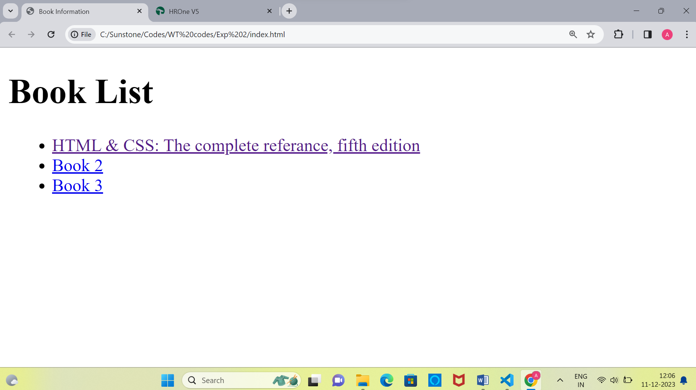

**Output: Book1 page**

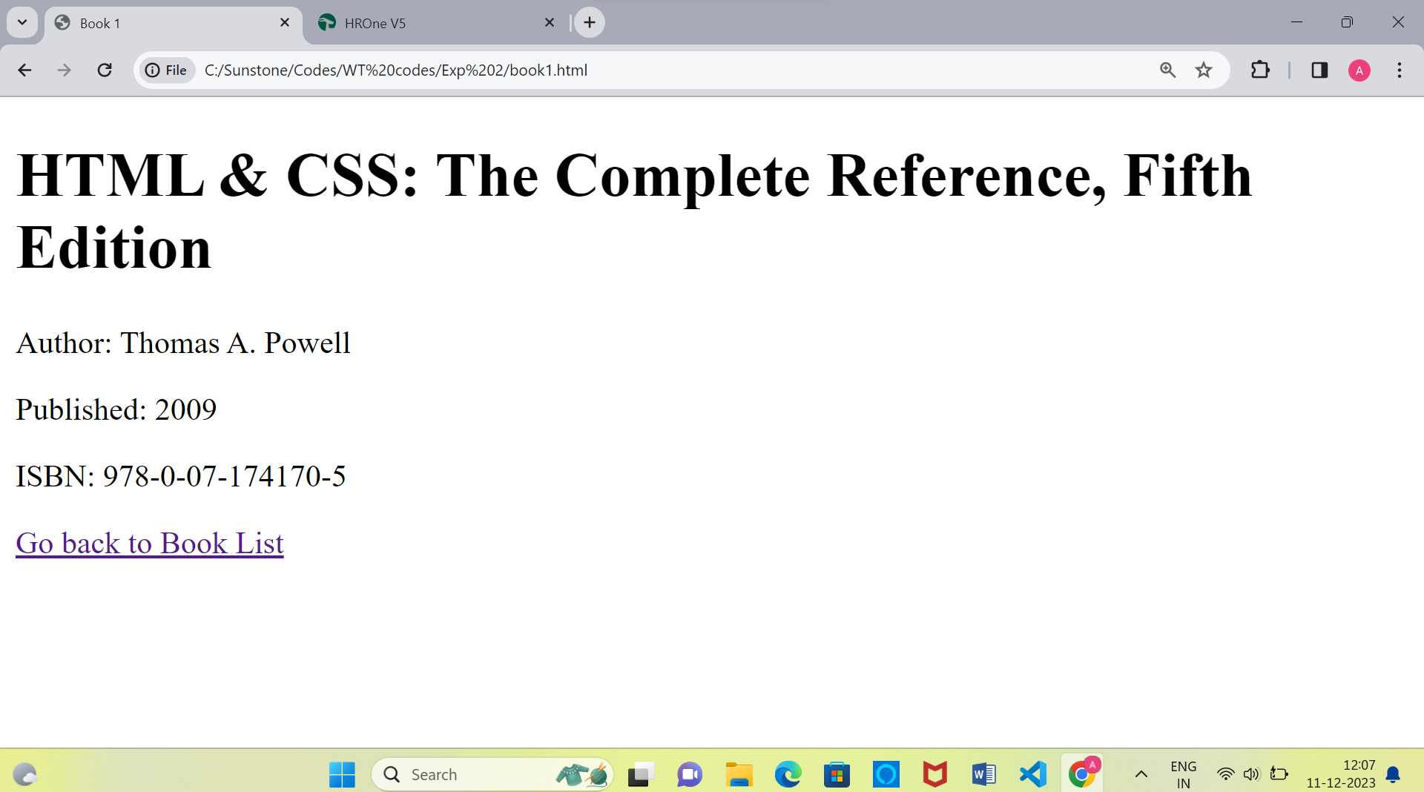

**Output: Book2 page**

**Paste screenshot of Book2 page**

**Output: Book3 page**

**Paste screenshot of Book3 page**

**Experiment 3**

**Objective:** 3. Design a page to display the product information such as name, brand, price and etc. on home page and when a product is clicked the description of the product will be displayed.

**Program : index.html**

<!DOCTYPE html>

<html>

<head>

    <title>Product Grid</title>

    <link rel="stylesheet" type="text/css" href="styles.css">

</head>

<body>

    <div class="product-grid">

        <div class="product">

            <a href="product1.html">

                <img src="./exp3.1/61u1VALn6JL._SL1500_.jpg" alt="Product 1">

                <h2>Product 1</h2>

            </a>

            <p class="price">Rs. 1287</p>

            <p class="description">Description of Product 1.</p>

        </div>

        <div class="product">

            <a href="product2.html">

                <img src="./exp3.1/original-samsung-ys-earphone-1000x1000.jpg" alt="Product 1">

                <h2>Product 2</h2>

            </a>

            <p class="price">Rs. 127</p>

            <p class="description">Description of Product 2.</p>

        </div>

        <div class="product">

            <a href="product3.html">

                <img src="./exp3.1/61FTRN2DPML._SL1500_.jpg" alt="Product 1">

                <h2>Product 1</h2>

            </a>

            <p class="price">Rs. 2287</p>

            <p class="description">Description of Product 3.</p>

        </div>

        <div class="product">

            <a href="product4.html">

                <img src="./exp3.1/61u1VALn6JL._SL1500_.jpg" alt="Product 1">

                <h2>Product 1</h2>

            </a>

            <p class="price">Rs. 127</p>

            <p class="description">Description of Product 4.</p>

        </div>

        <div class="product">

            <a href="product5.html">

                <img src="./exp3.1/61u1VALn6JL._SL1500_.jpg" alt="Product 1">

                <h2>Product 1</h2>

            </a>

            <p class="price">Rs. 1298</p>

            <p class="description">Description of Product 5.</p>

        </div>

        <div class="product">

            <a href="product6.html">

                <img src="./exp3.1/original-samsung-ys-earphone-1000x1000.jpg" alt="Product 1">

                <h2>Product 1</h2>

            </a>

            <p class="price">Rs. 287</p>

            <p class="description">Description of Product 6.</p>

        </div>

        <!-- Repeat the product structure for the other 8 products -->

    </div>

</body>

</html>

**Program : Product1.html**

<!DOCTYPE html>

<html>

<head>

    <title>Product 1 Details</title>

</head>

<body>

    <h1>Product 1</h1>

    <img src="product1.jpg" alt="Product 1">

    <p class="price">Rs. 1287</p>

    <p class="description">Description of Product 1.</p>

    <a href="index.html">Back to Product Grid</a>

</body>

</html>

**Program : Product2.html**

<!DOCTYPE html>

<html>

<head>

    <title>Product 2 Details</title>

</head>

<body>

    <h1>Product 1</h1>

    <img src="product1.jpg" alt="Product 1">

    <p class="price">Rs. 1287</p>

    <p class="description">Description of Product 1.</p>

    <a href="index.html">Back to Product Grid</a>

</body>

</html>

**Program : Product3.html**

**Paste your Code here**

**Program : Product4.html**

**Paste your Code here**

**Program : Product5.html**

**Paste your Code here**

**Program : Product6.html**

**Paste your Code here**

**Program : style.css**

body {

    font-family: Arial, sans-serif;

}

.product-grid {

    display: grid;

    grid-template-columns: repeat(3, 1fr);

    gap: 20px;

    padding: 20px;

}

.product {

    text-align: center;

    background-color: #f5f5f5;

    padding: 20px;

    border: 1px solid #ddd;

    border-radius: 5px;

}

.product img {

    max-width: 100%;

}

.price {

    color: #f36f6f;

    font-weight: bold;

}

a {

    text-decoration: none;

    color: #333;

}

img{

    height: 300px;

    width: 300px;

}

**Output: Product Grid Page**

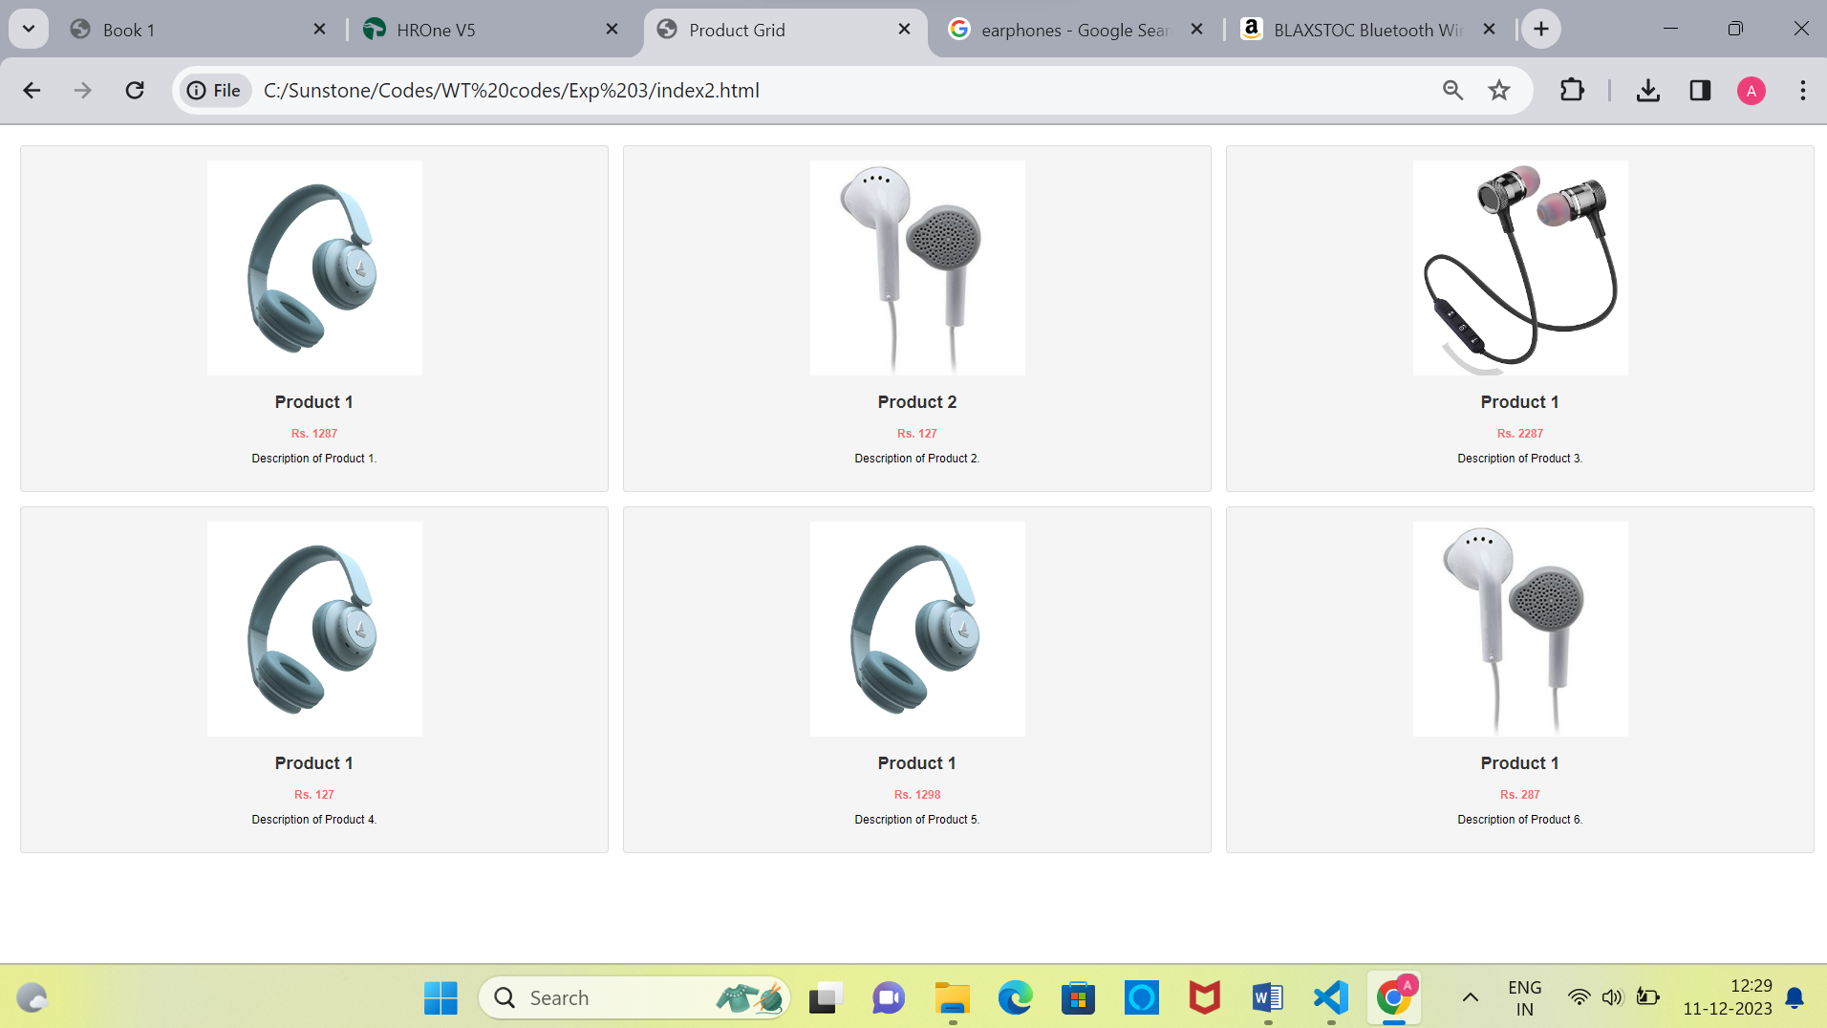

**Output: Product1 Page**

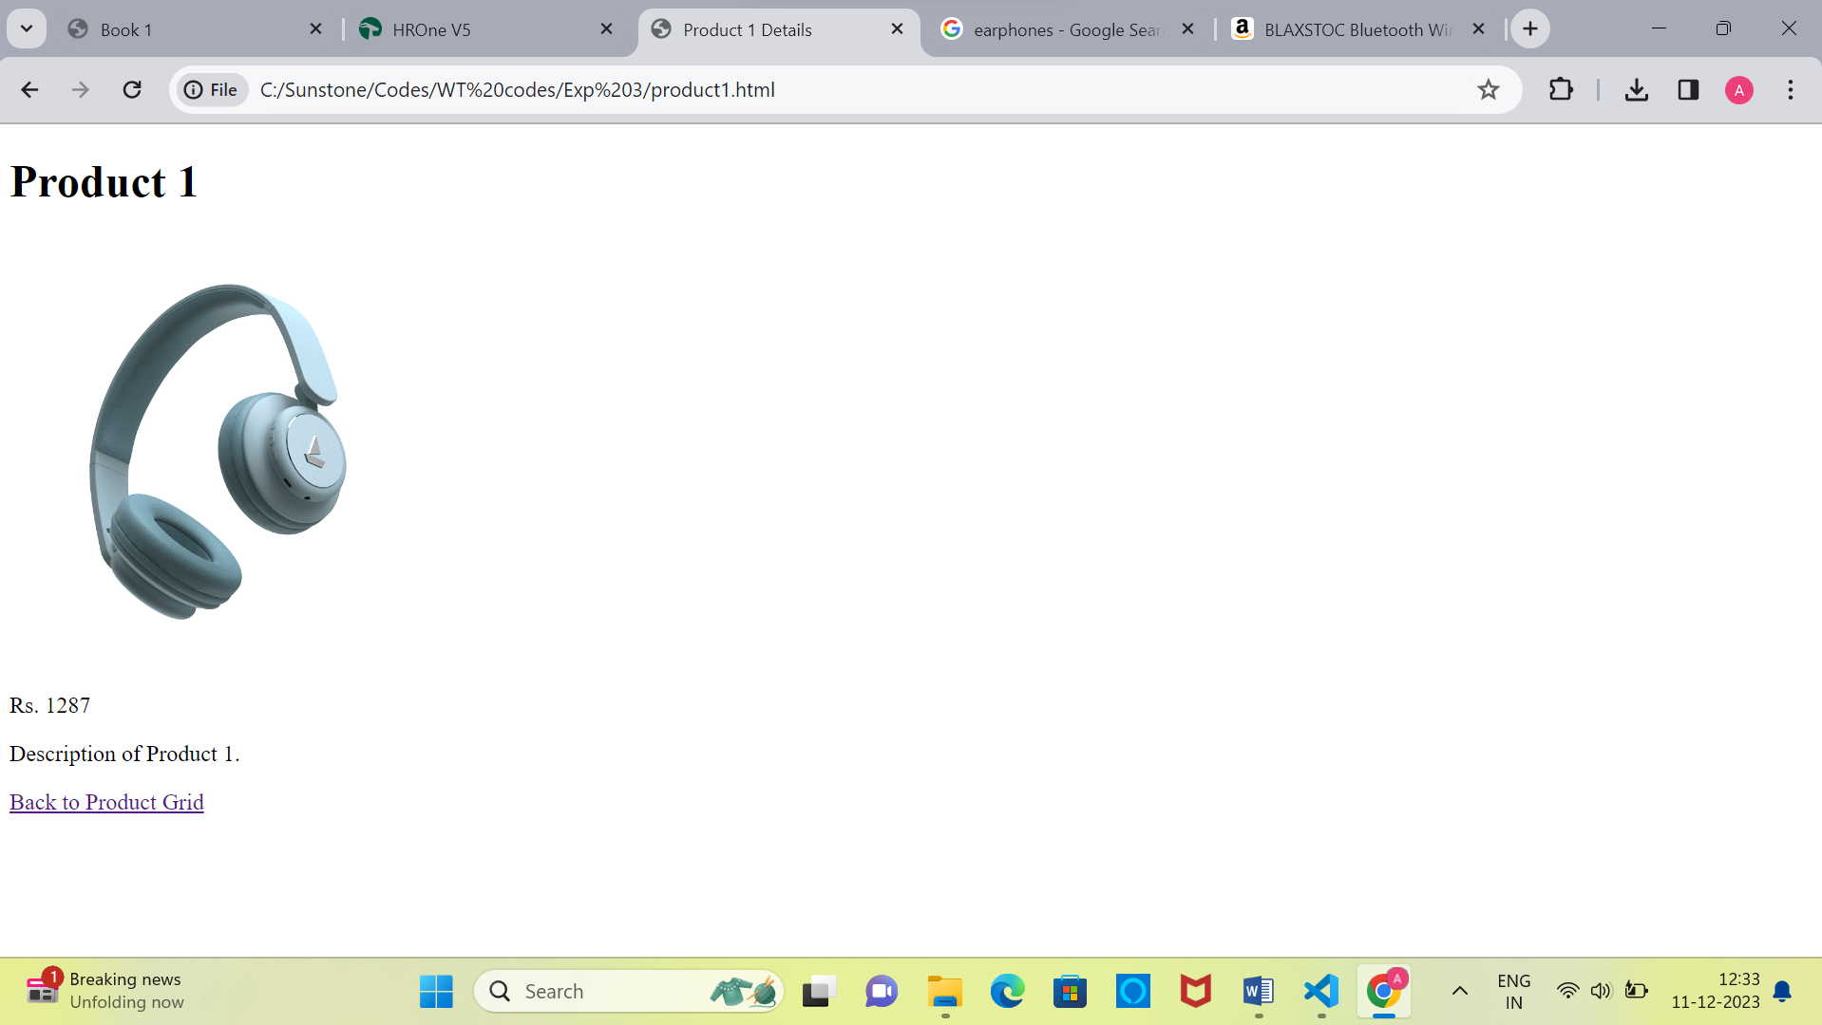

**Output: Product2 Page**

**Paste screenshot here**

**Output: Product3 Page**

**Paste screenshot here**

**Output: Product4 Page**

**Paste screenshot here**

**Output: Product5 Page**

**Paste screenshot here**

**Output: Product6 Page**

**Paste screenshot here**